ATTACHMENT VII
CDBG SPECIAL CONDITIONS
NOTE: This Grant Agreement represents a subaward of federal funds (see Attachment VII-E) and therefore includes certain compliance requirements. This Attachment must be included in all Grant Agreements and all Sub awards within them.

COMPENSATION AND METHOD OF PAYMENT
Notwithstanding estimated budget figure categories appearing in Attachments I and II, the Grantee must be reimbursed only for actual work completed and expenses incurred, which are supported by documentation in a form acceptable to the Department of Housing and Community Affairs (DHCA). In all cases, these budget amounts represent the maximum amount to be paid and must not be exceeded without prior written authorization from DHCA. Attachment VII-A describes the type of documentation required for invoicing.

The Grantee must request payment by submitting to DHCA a monthly invoice that describes each item of completed work in detail, accompanied by supporting backup documentation. DHCA may withhold payment to Grantees whose performance or data reporting is not in compliance with the Grant Agreement terms.
The Grantee may request in writing that DHCA transfer funds among the budget categories reflected in Attachments I and II, provided the total dollar value of the Grant Agreement is not altered and that there is no significant change in the scope of services provided. The total amount payable under this Grant Agreement, and the dollar value, must not be increased unless approved and amended in writing in advance by the Director of DHCA.
Expenses for all projects and programs under this Grant Agreement must be incurred during the Grant Agreement term. All requests for payment must be received by DHCA no later than 30 days after the expiration of this Grant Agreement, except for those expenses incurred between June 15 and June 30 of the year of expiration, in which case payment requests must be received by DHCA no later than July 7. Invoices received by DHCA after the applicable period has expired will not be approved for payment, and the dollar value of this Grant Agreement will be reduced accordingly.

If salaries are invoiced, a timesheet indicating the number of hours billed for each day of the billing period must be provided and must be signed by both the employee and their supervisor (or other Grantee-designated second Signatory). If the employee is partially paid with any other public funds during the billing period, such time billed for such funds must be indicated on the time sheets. All other invoiced costs must be supported by a copy of the original vendor invoice. All payments must include the following clause, signed by the Signatory of the Grant Agreement:

“By signing this report, I certify to the best of my knowledge and belief that the report is true, complete, and accurate, and the expenditures, disbursements and cash receipts are for the purposes and objectives set forth in the terms and conditions of the federal award. I understand that receipt of this federal CDBG from the County is contingent upon the award of the federal CDBG to the County. I am aware that any false, fictitious, or fraudulent information, or the omission of any material fact, may subject me to criminal, civil or administrative penalties for fraud, false statements, false claims or otherwise.”

TERM
The term of this Grant Agreement is set forth in the Memorandum or letter agreement that is a part of this agreement. Unless otherwise specified, the term is one year, commencing on the date of signature by the Montgomery County Office of Procurement. In extraordinary circumstances beyond the control of the Grantee, if DHCA determines it is in the County's best interest to do so, the Director of the Office of Procurement has the authority to extend the term of this Grant Agreement. Extensions of this Grant Agreement must be executed by an amendment and are contingent upon the Grantee being on the Grantee list.

Requests for such Grant Agreement period extensions must be made in writing prior to the Grant Agreement's expiration and must thoroughly describe the necessity for the delay. If DHCA requires it, such requests must specify in detail the steps that will be taken and establish measurable milestones that may be monitored to ensure the project will be completed during the requested time extension. Such extensions will be granted only for compelling causes and at the sole discretion of the County. Any funds not committed and/or expended as scheduled under such a plan, subject to a 30-day right for the Grantee to cure the defect, are subject to immediate recapture and reallocation by DHCA to other projects. Requests for modifications to Grant Agreement terms may adversely impact recommendations for future CDBG funding for the Grantee.

PROJECT INCOME
Certain income derived from this, and prior, CDBG-funded activities and projects, is classified as program income and is defined at 24 C.F.R. §570.500(a). Program income includes, but is not limited to, interests, rents, user fees, loan repayments, funds derived from the sale of property acquired or improved with CDBG funds, assessments, as well as other types of contributions.

In accordance with 24 C.F.R. §570.504, unless otherwise agreed in writing in advance by the parties, the Grantee must reflect all program income received during the invoiced period on each invoice submitted for work performed under this agreement. The Grantee, by presenting an invoice to the County, certifies that it has disclosed all program income received to that date. Any outstanding program income incurred, but not yet received, must be described with specificity in the documentation accompanying such invoice. Such program income must be applied first against the costs included in the invoice, unless an alternative arrangement has been previously approved in writing by DHCA. Adequate fiscal records must be maintained, clearly indicating the disposition of all program income, and these records must be maintained for the term described in section 7. Audit and Inspection.

REVIEW OF AGREEMENTS EXECUTED BY GRANTEE
To ensure compliance with all applicable HUD and other federal guidelines, the Grantee must submit all proposed contracts, agreements, subcontracts, and amendments for review and approval by DHCA prior to their execution. DHCA must conduct such reviews in a timely manner and provide written confirmation of its compliance or noncompliance with HUD requirements. Failure of the Grantee to obtain such advance approval will constitute grounds for DHCA’s refusal to make payment under such agreements.

ATTENDANCE AT MEETINGS
The Grantee must take all reasonable and necessary steps to achieve the successful completion of the work under this Grant Agreement. Such responsibilities include, but are not limited to, arranging and/or attending any necessary meetings, and coordinating all other resources required to implement the Scope of Services under this grant agreement.

FINANCIAL MANAGEMENT SYSTEM
In accordance with 2 C.F.R. Part 200, the Grantee, whether a non-profit corporation or municipality, must maintain a financial management system that provides, at a minimum, for the following for all CDBG funds:
  - Accurate, current, and complete disclosure of all financial activities under this grant agreement;
  - Records that identify the amounts of funding authorized, obligations, unobligated balances, assets, outlays, and incomes;
  - Effective control and accountability for all funds and for capital items purchased under this grant;
  - A comparison of actual outlays with budgeted amounts and the relationship between performance and costs incurred;
  - Accounting records that are supported by source documentation.

AUDIT AND INSPECTION
In accordance with 2 C.F.R. Part 200, a Grantee that expends $1,000,000 or more in a year in Federal awards must have a program-specific audit conducted for that year as specified in 2 C.F.R. §200.501. The Grantee must furnish DHCA with a copy of all audit reports within 30 days of receipt. If DHCA finds the audit report to contain findings or concerns, the Grantee must submit to DHCA, within 60 days of submitting the audit report, the Grantee’s plan of action for correcting all noted deficiencies. Should the Grantee fail to submit a plan or follow through on the necessary remedial actions in a timely manner, the Grant Agreement may be suspended or terminated under the provisions of section 20. Suspension and Termination.

For Grantees that spend less than $1,000,000 in Federal awards, DHCA will make an individual determination based on a risk assessment of the entity if an audit is required.
The Grantee agrees that the County, the U.S. Department of Housing and Urban Development, the Controller General of the United States, and any of their duly authorized representatives must, until the expiration of 3 years after completion of the Grant Agreement, have access to and the right to examine any pertinent books, documents, papers, and records of the Grantee and all sub-awards involving transactions related to the Agreement. DHCA reserves the right to request a longer document retention period in the event it may be required on a case-by-case basis.

REPORTING REQUIREMENTS
In accordance with the requirements of 24 C.F.R. §570.201 and 24 C.F.R. §570.506, the Grantee must electronically file quarterly Benefit Data Reports with the Department of Housing and Community Affairs for all quarters in which any portion of the Grant Agreement was active. The Grantee must retain these records until the period described in section 7. Audit and Inspection have expired. Each report must summarize the actual achievements of the project and relate these to its scope of services and stated goals. Each quarterly report must include all the data indicated on the sample Benefit Data Report shown in Attachment VII-B, and the Grantee must maintain backup documentation supporting the reported data. If the Grantee has negotiated and executed a sub-agreement, a fully executed Attachment VII-C, “Subcontract Activity Report,” must also be included.

The Grantee recognizes that programmatic requirements undergo periodic revisions and specifically agrees to provide all other information and/or reports that may be requested by DHCA consistent with compliance with internal controls or HUD requirements and regulations.

EQUAL OPPORTUNITY
Note: Executive Order 14173 (2023) supersedes prior workforce nondiscrimination provisions under Executive Order 11246.

During the performance of this Grant Agreement, the Grantee agrees as follows:
- The Grantee will not discriminate against any employee or applicant for employment . The Grantee will take action to ensure that applicants are employed, and that employees are treated equally . Such action shall include, but not be limited to the following: Employment, upgrading, demotion, or transfer, recruitment or recruitment advertising; layoff or termination; rates of pay or other forms of compensation; and selection for training, including apprenticeship. The Grantee agrees to post in conspicuous places, available to employees and applicants for employment, notices to be provided by the contracting officer setting forth the provisions of this nondiscrimination clause.
- The Grantee will, in all solicitations or advertisements for employees placed by or on behalf of the Grantee, state that all qualified applicants will receive consideration for employment .
- The Grantee will not discharge or in any other manner discriminate against any employee or applicant for employment because such employee or applicant has inquired about, discussed, or disclosed the compensation of the employee or applicant or another employee or applicant. This provision shall not apply to instances in which an employee who has access to the compensation information of other employees or applicants as a part of such employee's essential job functions discloses the compensation of such other employees or applicants to individuals who do not otherwise have access to such information, unless such disclosure is in response to a formal complaint or charge, in furtherance of an investigation, proceeding, hearing, or action, including an investigation conducted by the employer, or is consistent with the Grantee's legal duty to furnish information.

SUBCONTRACTING WITH MINORITY FIRMS
It is national policy to award a fair share of contracts and subcontracts to small and minority, female, and disability owned business firms. Accordingly, affirmative steps must be taken to ensure that such businesses are utilized when possible as sources of supplies, equipment, construction, and services. Affirmative steps must include the following:
- Including qualified small and minority businesses on solicitation lists;
- Assuring that small and minority businesses are solicited whenever they are potential sources;
- When economically feasible, dividing total requirements into smaller tasks or quantities so as to permit maximum small and minority business participation;
- Where the requirements permit, establishing delivery schedules which will encourage participation by small and minority businesses;
- Using the services and assistance of the Small Business Administration, the Office of Minority Business Enterprise of the Department of Commerce, and the Community Services Administration as required.

If any subcontracts are to be let, the prime contractor or grantee must take the affirmative steps in (a) through (e), above.

Montgomery County’s Department of Procurement has a Minority, Female and Disabled Persons Program which can be of assistance in identifying and accessing minority, female and disabled contractors. It can be reached at (240) 777-9912 / 9913 or https://www.montgomerycountymd.gov/PRO/DBRC/mfd.html.

AGREEMENTS WITH RELIGIOUS ORGANIZATIONS TO PROVIDE CDBG FUNDED PUBLIC SERVICES
In conjunction with, and not in substitution of, other requirements within this Agreement regarding the provision of public services with CDBG funds, pursuant to Title I of the Housing and Community Development Act of 1974, as amended, the Grantee:
- represents that if it is, or may be deemed to be, a religious or denominational institution or organization, or is an organization operated for religious purposes which is supervised or controlled by, or in connection with, a religious or denominational institution or organization; and
- it agrees that, in connection with such public services:
  - It will not discriminate against any employee or applicant for employment on the basis of religion and will not limit employment or give preference in employment to persons on the basis of religion;
  - It will not discriminate for or against any person applying for such public services on the basis of religion and will not limit, nor determine the scope of such public services on the basis of religion;

  - it will provide no religious instruction or counseling, conduct no religious worship or services, engage in no religious proselytizing, nor exert any other religious influence in the provision of such public services;
  - the portion of a facility used to provide public services assisted in whole or in part under this Agreement shall contain no sectarian or religious symbols or decorations; and

  - if funds received under this Agreement are used to acquire, construct, rehabilitate, or restore any facility which is owned by the Grantee, that facility must be held in trust by the faith-based organization as trustees for the beneficiaries of the project or program under which the property was acquired or improved, The faith-based organization must record liens or other appropriate notices of record to indicate that personal or real property has been acquired or improved with federal funds and that use and disposition conditions apply to the property. Acquisition or renovation of principal places of worship is prohibited.

COMPLIANCE WITH OTHER FEDERAL REGULATIONS
In accordance with 24 C.F.R. §570.502 (a) and (b), the Grantee must comply with all Federal laws, regulations, and requirements, including amendments thereto, applicable to CDBG grants and/or loans and any applicable HUD guidance issued after the date of this agreement.

- SIGNS/ADVERTISEMENTS- The Grantee must ensure that all signs, posters, pamphlets, printed materials, advertisements, and written articles concerning this program/project must include a statement acknowledging full or partial CDBG funding as appropriate.
- LOBBYING - The Grantee agrees and certifies, with respect to lobbying, to the following:
- No federal appropriated funds have been paid or will be paid, by or on behalf of the Grantee, to any person for influencing or attempting to influence an officer or employee of any agency, a Member of Congress, in connection with the awarding of any federal contract, the making of any federal grant or loan, the entering into of any cooperative agreement, and the extension, continuation, renewal, amendment, or modification of any federal contract, grant, loan or cooperative agreement.
- If any funds other than federal appropriated funds have been paid or will be paid to any person for influencing or attempting to influence an officer or employee of any agency, a Member of Congress, an officer or employee of Congress or an employee of a Member of Congress in connection with this federal contract, grant, loan or cooperative agreement, the Grantee must complete and submit an executed “Disclosure Form to Report Lobbying,” in accordance with instructions provided therein. Byrd Anti-Lobbying Amendment (31 U.S.C. 1352)—Contractors that apply or bid for an award exceeding $100,000 must file the required certification. Each tier certifies to the tier above that it will not and has not used Federal appropriated funds to pay any person or organization for influencing or attempting to influence an officer or employee of any agency, a member of Congress, officer or employee of Congress, or an employee of a member of Congress in connection with obtaining any Federal contract, grant or any other award covered by 31 U.S.C. 1352. Each tier must also disclose any lobbying with non-Federal funds that takes place in connection with obtaining any Federal award. Such disclosures are forwarded from tier to tier up to the non-Federal award.
- The Grantee must require that the language of this certification be included in the award documents implementing all sub- awards at all tiers (including subcontracts, sub grants, and contracts under grants, loans, and cooperative agreements) and that all subrecipients must certify and disclose accordingly.
- INVENTIONS/INTELLECTUAL PROPERTY - The Grantee may copyright any work that is subject to copyright and was developed, or for which ownership was acquired, under a Federal award. The Federal awarding agency reserves a royalty-free, nonexclusive, and irrevocable right to reproduce, publish, or otherwise use the work for Federal purposes, and to authorize others to do so.

CAPITAL EQUIPMENT
In accordance with 2 C.F.R. §200.1, equipment is defined as tangible personal property (including information technology systems) having a useful life of more than one year and a per-unit acquisition cost that equals or exceeds the lesser of the capitalization level established by the recipient or subrecipient for financial statement purposes, or $10,000. Generally, the purchase of equipment is prohibited. Prior to purchasing any equipment, the Grantee must obtain written permission from the County. The County reserves the right to purchase such equipment through its sources of supply if such a purchase will result in cost savings. Title to the equipment must remain with the County. Recipients must submit to the County annually, during the term of this agreement (and all extensions thereof), an inventory listing of all County-owned equipment in their custody. Attachment VI-D is provided for this purpose.

Upon completion of this agreement or at such time as the equipment is no longer needed by the Grantee, disposition of the equipment must be determined in accordance with 2 C.F.R. Section 200.313, and all dispositions must be approved in writing by the County prior to implementation.

PLANT INSPECTION
The County may inspect the place of business or location of service delivery of the Grantee under any grant or loan agreement awarded or to be awarded by the County or any subcontractor thereunder. The unreasonable failure of a bidder or offeror to supply information promptly in connection with such an inspection may be grounds for a determination of non-responsiveness by the County and will constitute a default under the terms of this agreement.

NON-PARTICIPATING CDBG JURISDICTIONS
Residents of, and facilities and programs located within municipalities that have chosen not to enter into CDBG Participation Agreements with the County are ineligible for receipt of all CDBG funded activities and benefits.

ENTIRE AGREEMENT
This grant agreement including all attachments constitutes the entire agreement between the parties. There are no other collateral grant agreements or agreements of any kind between the parties.

SUSPENSION AND TERMINATION
In accordance with 2 C.F.R. §200.208 suspension or termination may occur if the grantee materially fails to comply with any terms of this award. In addition, this award may be terminated for convenience in accordance with 2 C.F.R. §200.339.
- CONTRACTOR DEBARMENT or INELIGIBILITY – No contract may be awarded to a party listed as debarred or ineligible on the governmentwide exclusions in the System for Award Management (SAM). All entities with whom a contract or subcontract will be executed must be checked against those listings and dated verification of its status printed out prior to contract execution and included in the project file.

DOCUMENT AND RECORD RETENTION REQUIREMENTS
All documents, records and files must be maintained, and available for inspection on request, for a minimum period of three (3) years following the closeout of the project.

CONFLICT OF INTEREST
No persons who exercise or have exercised any functions or responsibilities with respect to CDBG activities, or who are in a position to participate in a decision making process or gain inside information with regard to such activities, may obtain a financial interest or benefit from a CDBG-assisted activity, or have a financial interest in any contract, subcontract, or agreement with respect to a CDBG- assisted activity, or with respect to the proceeds of the CDBG-assisted activity, either for themselves or those with whom they have business or immediate family ties, during their tenure or for one year thereafter.

NOTE. PARAGRAPHS 24 THROUGH 32 ARE APPLICABLE TO ALL FEDERALLY ASSISTED CONSTRUCTION CONTRACTS
Note: Executive Order 14173 (2023) supersedes prior nondiscrimination and affirmative‑action obligations under Executive Order 11246. The construction‑related clauses below are retained for continuity of federal contract language; however, compliance and enforcement must follow EO 14173.
- AFFIRMATIVE ACTION/EQUAL OPPORTUNITY FEDERALLY ASSISTED CONSTRUCTION CONTRACTS / GRANT AGREEMENTS
Except as otherwise provided, each administering agency shall require the inclusion of the following language as a condition of any grant, contract, loan, insurance, or guarantee involving federally assisted construction which is not exempt from the requirements of the equal opportunity clause:
The applicant hereby agrees that it will incorporate or cause to be incorporated into any contract for construction work, or modification thereof, as defined in the regulations of the Secretary of Labor at 41 C.F.R. Chapter 60, which is paid for in whole or in part with funds obtained from the Federal Government or borrowed on the credit of the Federal Government pursuant to a grant, contract, loan, insurance, or guarantee, or undertaken pursuant to any Federal program involving such grant, contract, loan, insurance, or guarantee, the following equal opportunity clause:
During the performance of this contract, the Grantee agrees as follows:
- The Grantee will not discriminate against any employee or applicant for employment because of race, color, religion, sex, sexual orientation, gender identity, or national origin. The Grantee will take affirmative action to ensure that applicants are employed, and that employees are treated during employment without regard to their race, color, religion, sex, sexual orientation, gender identity, or national origin. Such action shall include, but not be limited to the following:
Employment, upgrading, demotion, or transfer; recruitment or recruitment advertising; layoff or termination; rates of pay or other forms of compensation; and selection for training, including apprenticeship. The Grantee agrees to post in conspicuous places, available to employees and applicants for employment, notices to be provided setting forth the provisions of this nondiscrimination clause.
- The Grantee will, in all solicitations or advertisements for employees placed by or on behalf of the Grantee, state that all qualified applicants will receive consideration for employment without regard to race, color, religion, sex, sexual orientation, gender identity, or national origin.
- The Grantee will not discharge or in any other manner discriminate against any employee or applicant for employment because such employee or applicant has inquired about, discussed, or disclosed the compensation of the employee or applicant or another employee or applicant. This provision shall not apply to instances in which an employee who has access to the compensation information of other employees or applicants as a part of such employee's essential job functions discloses the compensation of such other employees or applicants to individuals who do not otherwise have access to such information, unless such disclosure is in response to a formal complaint or charge, in furtherance of an investigation, proceeding, hearing, or action, including an investigation conducted by the employer, or is consistent with the Grantee's legal duty to furnish information.
- The Grantee will send to each labor union or representative of workers with which he has a collective bargaining agreement or other contract or understanding, a notice to be provided advising the said labor union or workers' representatives of the Grantee's commitments under this section, and shall post copies of the notice in conspicuous places available to employees and applicants for employment.
- The following guidelines have been superseded by Executive Order 14173. The Grantee will comply with all provisions of Executive Order 11246 of September 24, 1965, and of the rules, regulations, and relevant orders of the Secretary of Labor.
- The following guidelines have been superseded by Executive Order 14173. The Grantee will furnish all information and reports required by Executive Order 11246 of September 24, 1965, and by rules, regulations, and orders of the Secretary of Labor, or pursuant thereto, and will permit access to his books, records, and accounts by the administering agency and the Secretary of Labor for purposes of investigation to ascertain compliance with such rules, regulations, and orders.
- The following guidelines have been superseded by Executive Order 14173. In the event of the Grantee's noncompliance with the nondiscrimination clauses of this contractor with any of the said rules, regulations, or orders, this contract may be canceled, terminated, or suspended in whole or in part and the Grantee may be declared ineligible for further Government contracts or federally assisted construction contracts in accordance with procedures authorized in Executive Order 11246 of September 24, 1965, and such other sanctions may be imposed and remedies invoked as provided in Executive Order 11246 of September 24, 1965, or by rule, regulation, or order of the Secretary of Labor, or as otherwise provided by law.
- The following guidelines have been superseded by Executive Order 14173. The Grantee will include the portion of the sentence immediately preceding paragraph (1) and the provisions of paragraphs (1) through (8) in every subcontract or purchase order unless exempted by rules, regulations, or orders of the Secretary of Labor issued pursuant to section 204 of Executive Order 11246 of September 24, 1965, so that such provisions will be binding upon each sub awardee vendor. The Grantee will take such action with respect to any subcontract or purchase order as the administering agency may direct as a means of enforcing such provisions, including sanctions for noncompliance:
Provided, however, that in the event a Grantee becomes involved in, or is threatened with, litigation with a sub awardee or vendor as a result of such direction by the administering agency, the Grantee may request the United States to enter into such litigation to protect the interests of the United States.
The applicant further agrees that it will be bound by the above equal opportunity clause with respect to its own employment practices when it participates in federally assisted construction work: Provided, That if the applicant so participating is a State or local government, the above equal opportunity clause is not applicable to any agency, instrumentality or subdivision of such government which does not participate in work on or under the contract.
The applicant agrees that it will assist and cooperate actively with the administering agency and the Secretary of Labor in obtaining the compliance of Grantees and sub awardees with the equal opportunity clause and the rules, regulations, and relevant orders of the Secretary of Labor, that it will furnish the administering agency and the Secretary of Labor such information as they may require for the supervision of such compliance, and that it will otherwise assist the administering agency in the discharge of the agency's primary responsibility for securing compliance.
The following guidelines have been superseded by Executive Order 14173:
The applicant further agrees that it will refrain from entering into any contract or contract modification subject to Executive Order 11246 of September 24, 1965, with a contractor debarred from, or who has not demonstrated eligibility for, Government contracts and federally assisted construction contracts pursuant to the Executive Order and will carry out such sanctions and penalties for violation of the equal opportunity clause as may be imposed upon Grantees and sub awardees the administering agency or the Secretary of Labor pursuant to Part II, Subpart D of the Executive Order. In addition, the applicant agrees that if it fails or refuses to comply with these undertakings, the administering agency may take any or all of the following actions: Cancel, terminate, or suspend in whole or in part this grant (contract, loan, insurance, guarantee); refrain from extending any further assistance to the applicant under the program with respect to which the failure or refund occurred until satisfactory assurance of future compliance has been received from such applicant; and refer the case to the Department of Justice for appropriate legal proceedings.
- MISCELLANEOUS MANDATORY CONSTRUCTION CONTRACT INCLUSIONS FEDERALLY ASSISTED CONSTRUCTION CONTRACTS/GRANT AGREEMENTS
The following guidelines have been superseded by Executive Order 14173:
  - Subcontracts. Each nonexempt prime contractor or subcontractor shall include the equal opportunity clause in each of its nonexempt subcontracts.
  - Inclusion of the equal opportunity clause by reference. The equal opportunity clause may be included by reference in all Government contracts and subcontracts, including Government bills of lading, transportation requests, contracts for deposit of Government funds, and related instruments.
  - Incorporation by operation of the order. By operation of the order, the equal opportunity clause shall be considered to be a part of every contract and subcontract required by the order and the regulations in this part to include such a clause whether or not it is physically incorporated in such contracts and whether or not the contract between the agency and the contractor is written.
  - Adaptation of language. Such necessary changes in language may be made in the equal opportunity clause as shall be appropriate to identify properly the parties and their undertakings.
- KICKBACKS - FEDERALLY ASSISTED CONSTRUCTION CONTRACTS / GRANT AGREEMENTS
The Grantee is prohibited from inducing by any means any person employed in federally funded construction or repair work to give up any part of the compensation to which he is otherwise entitled, and must comply with all other provisions of the Copeland “Anti-Kick Back” Act, 18 U.S.C. 874, supplemented by Department of Labor Regulations 29 C.F.R. Part 3.
- LEAD BASED PAINT - FEDERALLY ASSISTED CONSTRUCTION CONTRACTS/GRANT AGREEMENTS
The use of all lead-based paint is prohibited, and the disturbance of certain existing surfaces which may potentially contain lead paint is subject to HUD LEAD-BASED PAINT POISONING PREVENTION IN CERTAIN RESIDENTIAL STRUCTURES described at 24
C.F.R. Part 35. DHCA and HUD consider reduction of exposure to lead paint hazards a priority. Grantees that disturb, or cause to be disturbed, surfaces potentially containing lead paint products must follow the specific protocols mandated by the state of Maryland and by HUD. Testing, notification and/or abatement may be required. Results of lead testing for all pre-1978 properties must be provided to DHCA prior to issuing any proposal for renovation or starting any renovation work. Additional information may be obtained by calling 1-800-424-LEAD.
- PROCUREMENT OF RECOVERED MATERIALS - FEDERALLY ASSISTED CONSTRUCTION CONTRACTS / GRANT AGREEMENTS
Procurement of recovered materials. Contractors must comply with section 6002 of the Solid Waste Disposal Act, as amended by the Resource Conservation and Recovery Act. The requirements of Section 6002 include procuring only items designated in guidelines of the Environmental Protection Agency (EPA) at 40 C.F.R. part 247 that contain the highest percentage of recovered materials practicable, consistent with maintaining a satisfactory level of competition.

- SECTION 3 - FEDERALLY ASSISTED CONSTRUCTION CONTRACTS/GRANT AGREEMENTS

HUD’s Section 3 regulations were updated in 2020. Any reference to former 24 C.F.R. Part 135 shall be interpreted pursuant to the current HUD Section 3 rule at 24 C.F.R. Part 75.

The funding for the work to be performed under this grant agreement is assisted under a program providing direct Federal financial assistance from the Department of Housing and Urban Development and is subject to the requirements of Section 3 of the Housing and Urban Development Act of 1968, as amended, and the implementing regulations at 24 C.F.R. Part 75 (which replaced former Part 135 effective November 30, 2020). Section 3 requires that to the greatest extent feasible, opportunities for training and employment be given to lower income residents of the project area, and opportunities for provision of supplies and materials in connection with the project be awarded to business concerns located in, or owned in substantial part by persons residing in, the area of the project. Because of the demographic makeup of Montgomery County, the “project area” may be defined in a manner most likely to result in the actual award of such Section 3 benefits. HUD’s updated Section 3 rule at 24 C.F.R. Part 75 now defines ‘Targeted Section 3 workers’ using service‑area–based criteria; project area definitions in this Attachment remain valid and should be applied consistent with the updated rule.
The Grantee must certify and agree that it is under no contractual or other disability which would prevent it from complying with any of the requirements referenced or specified herein. The Grantee must include this Section 3 clause in every contract and subcontract for work in connection with the federally funded project and must, at the direction of the County, take appropriate action upon a finding that the subcontractor in violation of these regulations. For clarity, all references to former Section 3 regulations at 24 C.F.R. Part 135 shall be interpreted pursuant to the current Section 3 rule codified at 24 C.F.R. Part 75. The Grantee must not award or execute any subcontract unless the subcontractor first provides the Grantee with acceptable documentation regarding its ability to comply with the requirements of these regulations.

The Grantee must send to each representative of workers or labor organization, with whom it has a collective bargaining agreement or other grant agreement or understanding, if any, a notice advising the said labor organization or workers’ representative of its commitments under this Section 3 clause and must post copies of the notice in conspicuous places available to employees and applicants for employment or training.

Copies of the Section 3 regulations (now codified at 24 C.F.R. Part 75) are available from the Department of Housing and Community Affairs, 1401 Rockville Pike, Fourth Floor, Rockville, Maryland 20852, telephone number 240-777-3600. Section 3 and other federal regulations are also available on the World Wide Web at http://www.hud.gov.

COMPLIANCE WITH CLEAN AIR AND WATER ACT (For contracts in Excess of $100,000)
The Grantee must comply with all applicable standards, orders, and regulations issued pursuant to the Clean Air Act of 1970 (42 U.S.C. 7401 et seq.) and the Federal Water Pollution Control Act (33 U.S.C. 1251 et seq.), as amended, and subsequently related promulgated regulations and interpretations.

- CONTRACTOR DEBARMENT/INELIGIBILITY- FEDERALLY ASSISTED CONSTRUCTION CONTRACTS/GRANT AGREEMENTS
No contract may be awarded to a party listed as debarred or ineligible on the governmentwide exclusions in the System for Award Management (SAM). All entities with whom a contract or subcontract will be executed must be checked against those listings and dated verification of its status printed out prior to contract execution and included in the project file.
- FEDERAL LABOR STANDARDS AND OTHER FEDERAL REQUIREMENTS – FEDERALLY ASSISTED CONSTRUCTION CONTRACTS/ GRANT AGREEMENTS

For all contracts involving construction activities exceeding $2,000 (29 C.F.R. §5.5) the Federal Labor Standards Provisions, including but not limited to all Davis-Bacon related requirements, are applicable and are made a part of this contract. The Grantee, all contractors and all subcontractors must include these provisions in all agreements relative to covered work. The Grantee is responsible for compliance with the terms thereof on the part of all contractors and subcontractors funded under this Agreement. The Grantee must guarantee and provide payment of all restitution and/or penalties incurred as a result of failure to comply with these requirements, on behalf of all tiers of contractors performing work on a covered project:
- The “FEDERAL LABOR STANDARDS COMPLIANCE PACKET” and
- A current project-specific Davis-Bacon Wage Rate Determination (issued for this project only) which must be posted conspicuously at the job site during all phases of construction.

Current Davis‑Bacon wage determinations are published on the SAM.gov Wage Determination website. The Grantee must ensure that the applicable, project‑specific wage determination is posted at the job site and incorporated into all construction contracts.

IF YOUR PROJECT INVOLVES CONSTRUCTION, THIS ATTACHMENT SHOULD BE IMMEDIATELY FOLLOWED BY A COPY OF THE “FEDERAL LABOR STANDARDS PROVISIONS ATTACHMENTS PACKET” AS WELL AS PROJECT-SPECIFIC WAGE RATE DETERMINATION. IF THESE DOCUMENTS ARE MISSING, CONTACT THE CONTRACT MONITOR BEFORE EXECUTING THIS OR ANY OTHER CONSTRUCTION- RELATED INSTRUMENT.

ATTACHMENT VII-A
DOCUMENTATION FOR INVOICING
Federal and County regulations require appropriate documentation for all requests for CDBG funds. The Grantee must submit original documentation of all expenses claimed when submitting requests for payment. The County will not process any invoices unless the proper back-up documentation is included. DHCA reserves the right to request additional or supplemental documentation for any item for which reimbursement is requested under this agreement and to withhold payment if acceptable documentation is not provided.
GENERAL REQUIREMENTS: Invoices must:
- Be on the Grantee’s letterhead
- Include the Grant Agreement
- Include the Purchase Order number
- Include a Grantee Generated Invoice Number that is UNIQUE and SEQUENTIAL (such as 1, 2, 3, etc.)
- Indicate the dates of the period covered by the billing
- Describe and list the attached documentation (copies of original invoices, timesheets, etc.) and
- Be signed by the person who signed the contract (or a designee approved by DHCA in writing)
- Time sheets must reflect number of Grant hours worked each day and be signed by the employee and a designated Signatory of the Grantee. Employees partially funded with other public funds must indicate those funded hours on time sheets.

WHEN PREPARING PAYMENTS PLEASE ENSURE THAT:
- The math is correct
- The invoiced expense was incurred within the contract period (does not precede the date of the Notice to Proceed and is not after the contract expiration date)
- All Benefit Data Reports (and other reporting requirements in the Grant Agreement such as Semi- Annual Reports for County funded contracts) are current and that deliverables are being provided consistent with the contract terms
- Adequate unexpended funds remain under the contract to cover the invoice
- The categories of the billed amounts are consistent with the budget categories in the contract
- The amounts are consistent with the budget categories allocated for each line item
- The quantities reflected on the cover sheet are consistent with those in the back up information
- All necessary backup documentation is attached (timesheets, copies of original vendor invoices, receipts, etc.)
- Signed time sheets for employees without duplication of hours from other publicly funded sources
- Copies of original invoices for reimbursement

ATTACHMENT VII-B
INSTRUCTIONS FOR SUBMITTING QUARTERLY BENEFIT DATA REPORTS ONLINE

The Department of Housing and Urban Development (HUD) requires all grantees submit demographic information on clients served. Grantees must electronically submit Quarterly Benefit Data Reports (BDR’s) to DHCA for all quarters during which any period of the Grant Agreement is active. These BDR’s must be submitted no later than the 15th of the month following the quarter reported.

Failure to submit complete, accurate and timely reports may delay payments of Grantees’ invoices and result in early termination of the Grant Agreement, and the recapture by DHCA of any remaining unexpended Grant Agreement monies.

FY26 CDBG INCOME LIMITS (6/2025)

Section 8 Definition: | Extremely Low | Very Low | Low
CDBG Definition: | Very Low | Low | Moderate
Family Size | (30% of median) | (50% of median) | (80% of median*)
1 | $34,450 | $57,400 | $74,800
2 | $39,350 | $65,600 | $85,450
3 | $44,250 | $73,800 | $96,150
4 | $49,150 | $81,950 | $106,800
5 | $53,100 | $88,550 | $115,350
6 | $57,050 | $95,100 | $123,900
7 | $60,950 | $101,650 | $132,450
8 | $64,900 | $108,200 | $141,000
* The CDBG moderate-income limit for Montgomery County as periodically updated by HUD, with the understanding that the name of that category (CDBG 80%) is arithmetically less than 80% of Local Area Median Income, because it is capped by a HUD formula indexing it to the Section 8 income limits. This limit is approximately 64% of AMI.

(NOTE: DHCA has updated its electronic CDBG Benefit Data Reporting process. The content of the data to be reported has not changed. Only the submittal process has been modified.)

You are no longer required to log on and enter a password into an on-line program. Instead, you just download a form to your computer, fill it out, and email it in. The timing and frequency of the reporting has not changed. This should also assist you in being able to retain an electronic copy of your reports.

The format of the form is a fillable PDF (see sample on following pages). When you open it, you just tab to the fields and use the pull-down menus to fill in and enter the data or type data in the first three fields. Then enter your numerical data. When you are finished, you can use “Save As” and submit that version and you will have an original form to fill in next cycle or, you can download a fresh form each time.

Please download the reporting form at:

https://www.montgomerycountymd.gov/DHCA/grants/cdbg.html

You can open the form using Acrobat Reader or any other compatible PDF reader, fill it out, and email it to your assigned contract monitor. If you have questions or are experiencing problems, please contact your contract monitor directly.

The next two pages are a copy of the form on which you will enter your data so you can ensure that your information is gathered and documented appropriately for submitting in this format. DO NOT USE THIS SAMPLE FORM – DOWNLOAD THE FILLABLE PDF FORM

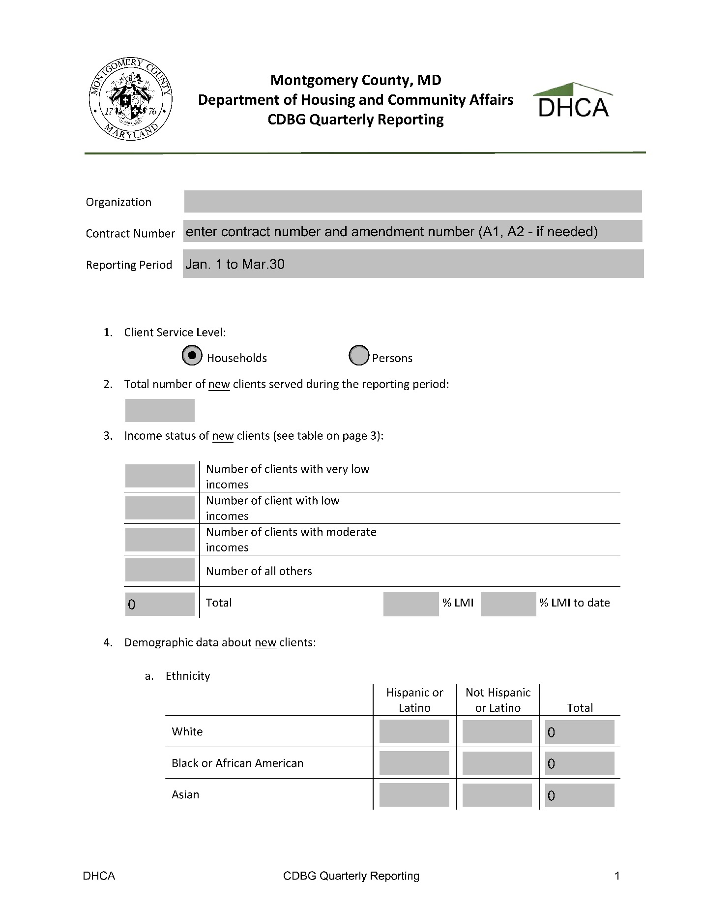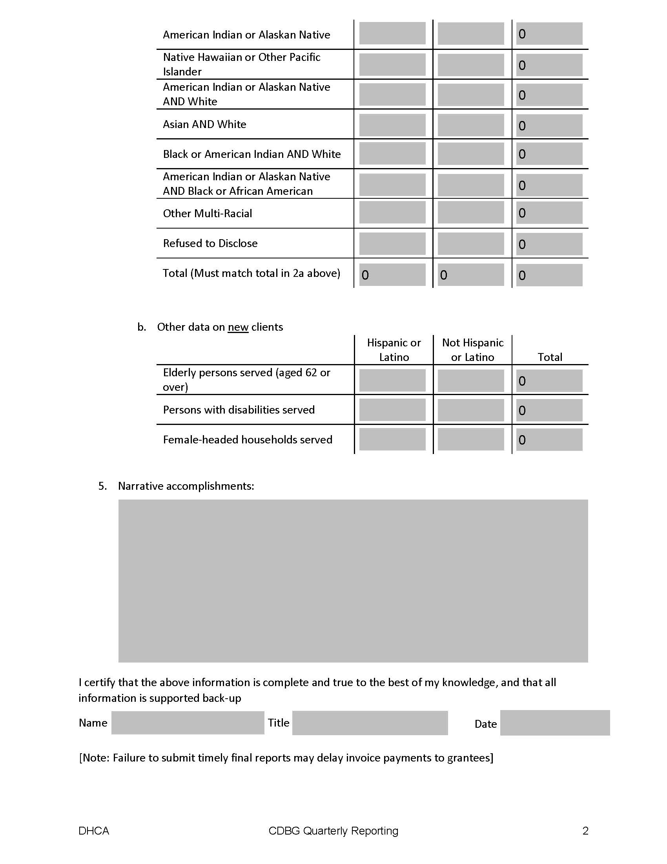

ATTACHMENT VII-C
SUBCONTRACT ACTIVITY REPORT

Submit to DHCA by 15th of the month after the quarter ends

Name of Subcontract Number 1:___________________________________________________
Date of Subcontract: |  | Dollar Amount:
Name of Subcontractor:
Mailing Address
Federal ID Number
Subcontract for: (check one) | [ ] Construction [ ] Education/Training [ ]Other:
Ethnic Code: (check one) 51% of Company Ownership is:
[ ] White [ ] Black [ ] American Indian/Alaskan [ ] Hispanic [ ] Asian/Pacific Islander

Name of Subcontract Number 2:___________________________________________________
Date of Subcontract: |  | Dollar Amount:
Name of Subcontractor:
Mailing Address
Federal ID Number
Subcontract for: (check one) | [ ] Construction [ ] Education/Training [ ]Other:
Ethnic Code: (check one) 51% of Company Ownership is:
[ ] White [ ] Black [ ] American Indian/Alaskan [ ] Hispanic [ ] Asian/Pacific Islander

CDBG Project Name:
Report filed by:
Title: |  | Date:

FOR DHCA USE ONLY:

Project Number: |  | Reviewed by:
Date: |  | Included in HUD Report

ATTACHMENT VII-D
CAPITAL EQUIPMENT INVENTORY

Submit to DHCA by July 15th of each year

Reporting period: July 1, to June 30,

Equipment Purchased | Date Purchased | Cost*
* Report all Capital equipment valued over $5,000.00 CDBG

Project Name:
Report filed by:
Title: |  | Date:

FOR DHCA USE ONLY:

Project Number: |  | Reviewed by:
Date: |  | Included in HUD Report

ATTACHMENT VII-E
FY 26 (FFY 25) COMMUNITY DEVELOPMENT BLOCK GRANT (CDBG) SUBAWARD INFORMATION
Subrecipient name  Must match the name associated with UEI | See attached grant agreement
Subrecipient unique entity identifier (UEI) | See attached grant agreement
Federal Award Identification Number (FAIN) | B25-UC-24-001
Federal Award Date | See Grant Agreement for B25-UC-24-001 on Montgomery County’s Website at:  https://montgomerycountymd.gov/dhca/grants/conplan.html
Subaward period of performance START DATE | The Contract will become effective upon signature of the Director, Office of Procurement (“Director”).
Subaward period of performance END DATE | This Contract will expire when the work has been completed or 12 months from the  effective date of this Contract
Amount of Federal Funds Obligated in the subaward | See attached grant agreement
Total Amount of Federal Funds Obligated to the subrecipient by the pass-through entity (MCG), including the current financial obligation | See attached grant agreement
Total Amount of the Federal Award committed to the subrecipient by the pass-through entity (MCG) | See attached grant agreement
Federal award project description, as required by the Federal Funding Accountability and Transparency Act (FFATA) | See Annual Action Plan posted on Montgomery County’s Website at: https://montgomerycountymd.gov/dhca/grants/conplan.html
Name of the Federal agency | 14.001-14.999 HOUSING AND URBAN DEVELOPMENT
Name of Pass-Through Entity (must match name associated with Pass through entity’s UEI) | See attached grant agreement
Awarding Official Contract (Pass Through Entity) | Department of Housing and Urban Development, Montgomery County, Maryland  Contact info: Katherine Canales 240-777-3631
Assistance Listings title and number;  The pass-through entity must identify the dollar amount made available under each Federal award and the Assistance Listings Number at the time of disbursement | Same as on attached Grant Agreement unless otherwise noted here
Identification of whether the Federal award is for research and development | NO
Indirect cost rate for the Federal award (including if the de minimis rate is used in accordance with 2 C.F.R. §200.414) | NA

